**DIGITAL SYSTEMS**

**PRACTICUM 12**



**By:**

**ARIA WIDIYO NOVIYANTO**

**NIM: L200183043**

**INFORMATION TECHNOLOGY**

**FACULTY OF COMMUNICATION AND INFORMATICS**

**UNIVERSITY OF MUHAMMADIYAH SURAKARTA**

**Experiment 1**

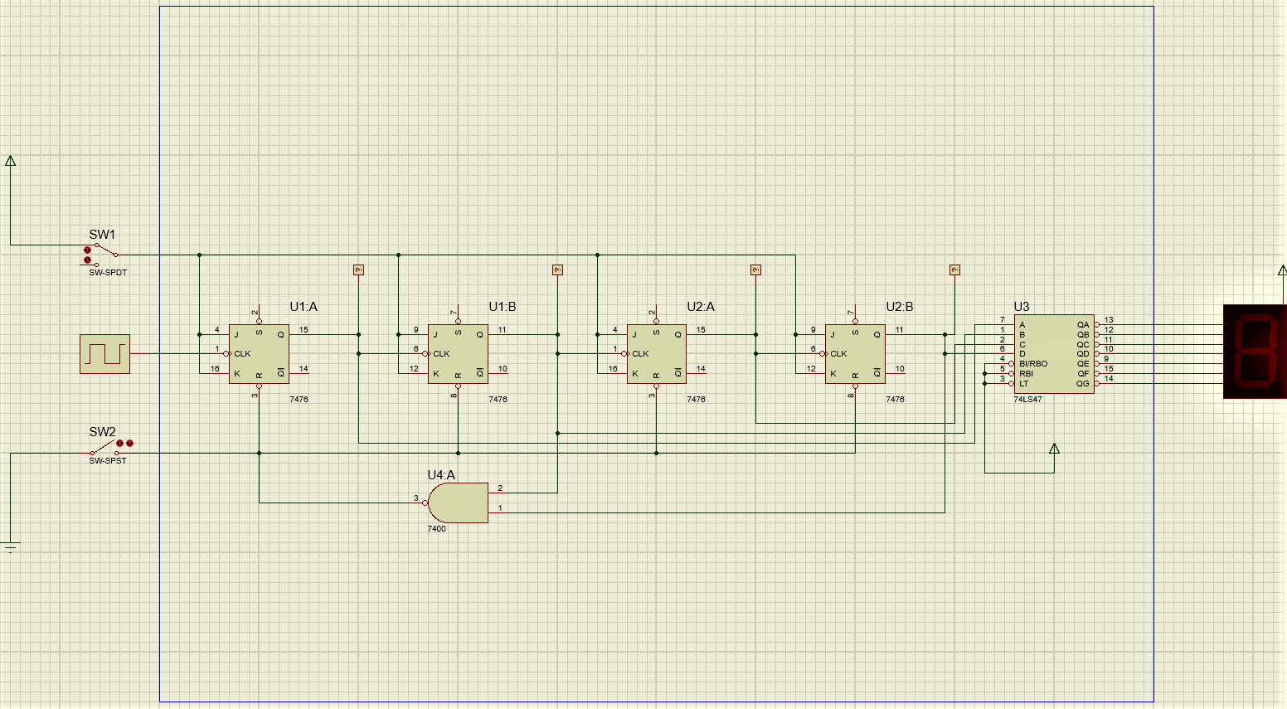

Picture 1.1. Modulus 10 and Decoder circuit

1. What is the output seen in the seven segment?

Answer: The seven segment output is in the form of calculations from 1 to 9.

**Experiment 2**

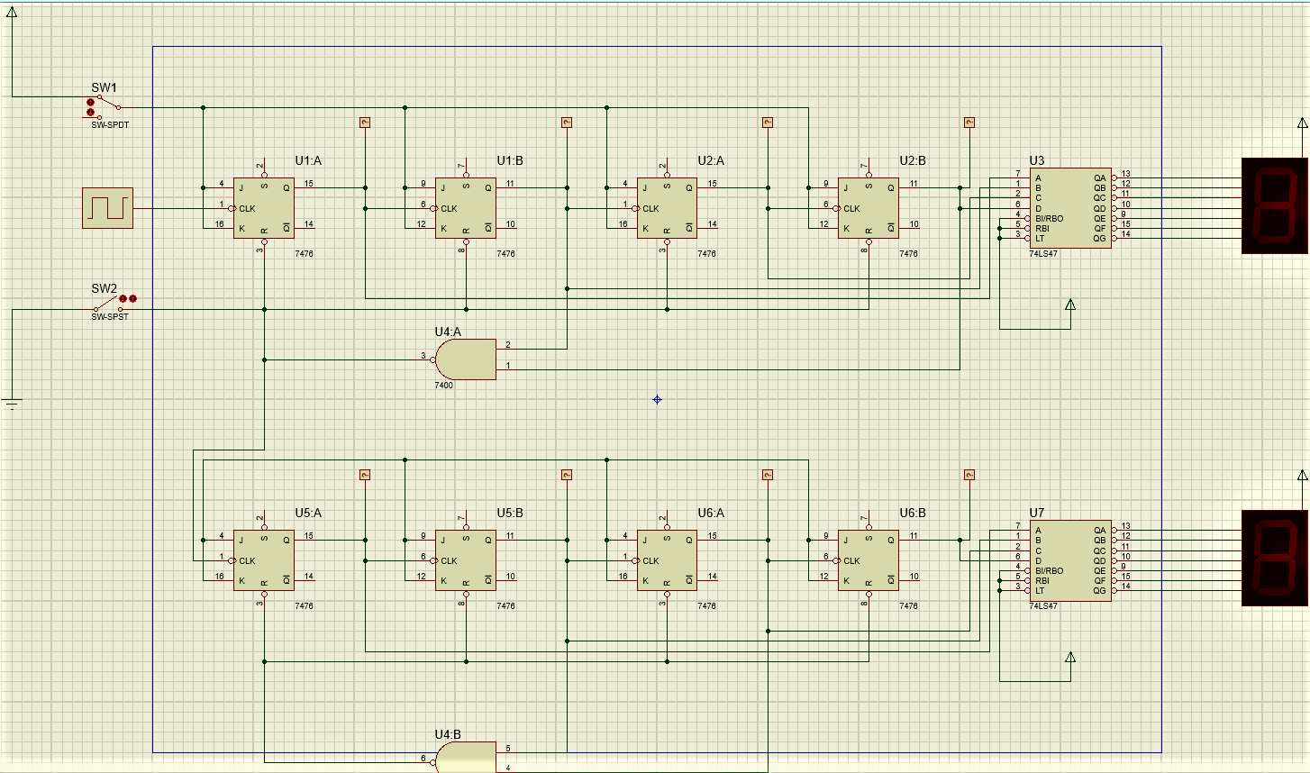

Picture 2.1. Modulus 6 and Decoder circuit

1. What is the clock function in the series above?

Answer: To determine the speed of calculation.

1. Explain the usefulness of the SPDT Switch in the series above!

Answer: To check the value of the decoder.

1. Explain the usefulness of the SPST Switch in the series above!
2. Answer: To stop counting.